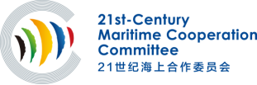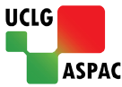
The 8th 21st-Century Maritime Cooperation Committee Meeting
October 10, 2022丨Daejeon, the ROK
Participation Form

Please complete this form and submit it to the Secretariat of the 21st-Century Maritime Cooperation Committee via E-mail: secretariat_21CMCC@163.com

Attendees:
No.1 | Full Name | □Mr. □Ms. | Given Name | Middle Name | Family Name
No.1 | Position
No.1 | Organization
No.1 | Participation Type | □ In Person □ Online
No.2 | Full Name | □Mr. □Ms. | Given Name | Middle Name | Family Name
No.2 | Position
No.2 | Organization
No.2 | Participation Type | □ In Person □ Online

Contact:
Full Name | □Mr. □Ms. | Given Name | Middle Name |  | Family Name
Position
Organization
Contact Methods | Tel: |  |  | Fax:
Contact Methods | Email:

